New Wheels Project

Introduction to SQL

Problem Statement
Business Context
A lot of people in the world share a common desire: to own a vehicle. A car or an automobile is seen as an object that gives the freedom of mobility. Many now prefer pre-owned vehicles because they come at an affordable cost, but at the same time, they are also concerned about whether the after-sales service provided by the resale vendors is as good as the care you may get from the actual manufacturers.
New-Wheels, a vehicle resale company, has launched an app with an end-to-end service from listing the vehicle on the platform to shipping it to the customer's location. This app also captures the overall after-sales feedback given by the customer.
Objective
New-Wheels sales have been dipping steadily in the past year, and due to the critical customer feedback and ratings online, there has been a drop in new customers every quarter, which is concerning to the business. The CEO of the company now wants a quarterly report with all the key metrics sent to him so he can assess the health of the business and make the necessary decisions.
As a data analyst, you see that there is an array of questions that are being asked at the leadership level that need to be answered using data. Import the dump file that contains various tables that are present in the database. Use the data to answer the questions posed and create a quarterly business report for the CEO.

Business Questions

Question 1: Find the total number of customers who have placed orders. What is the distribution of the customers across states?
Solution Query:
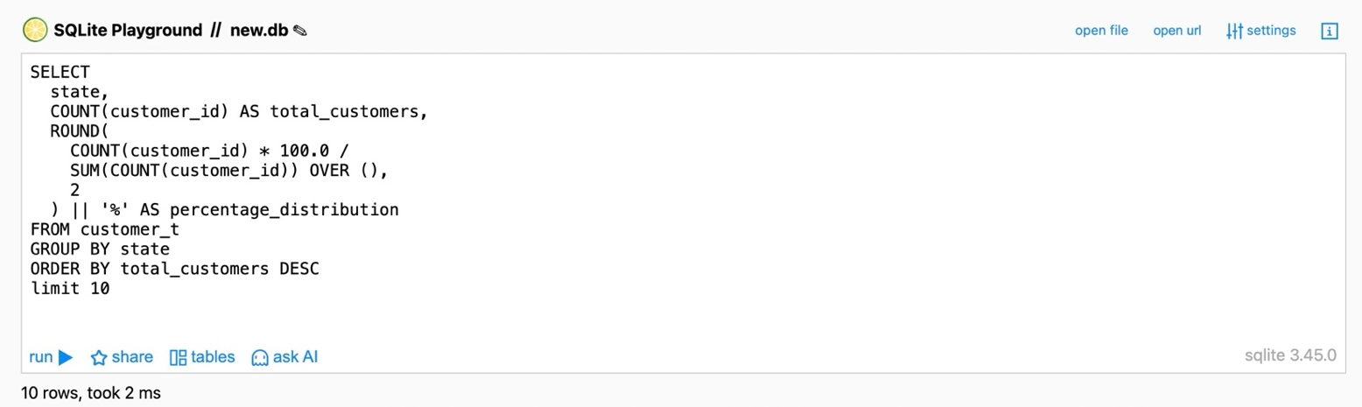
Output:
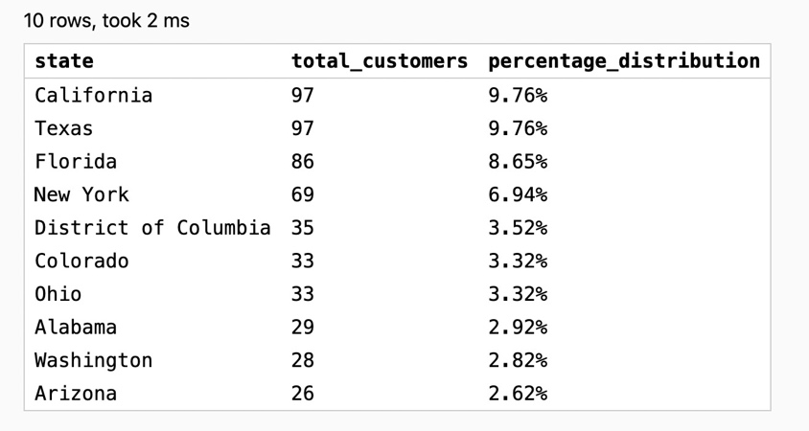
Observations:
- ~994 customers have placed orders across multiple states
- California and Texas are the largest markets, each contributing ~10% of total customers
- Florida (8.65%) and New York (6.94%) are the next key contributors
- The top 4 states contribute ~35% of the total customer base
- Remaining states individually contribute below 4%, indicating a long-tail distribution

Insights:
- Customer demand is concentrated in major states, making them critical to revenue stability
- Any negative after-sales experience in top states can significantly impact overall sales trends
- Mid- and low-performing states present growth opportunities through targeted expansion and service improvement
- Diversifying customer acquisition across states can reduce dependency on a few key markets

Question 2: Which are the top 5 vehicle makers preferred by the customers?
Solution Query:
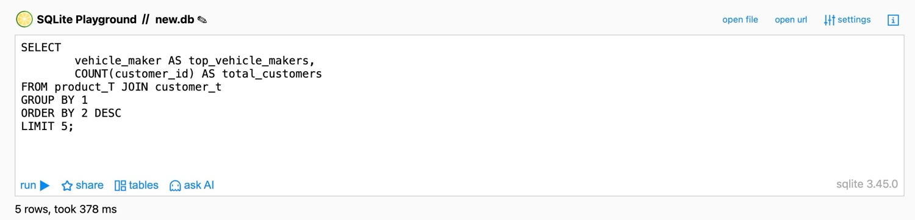
Output:
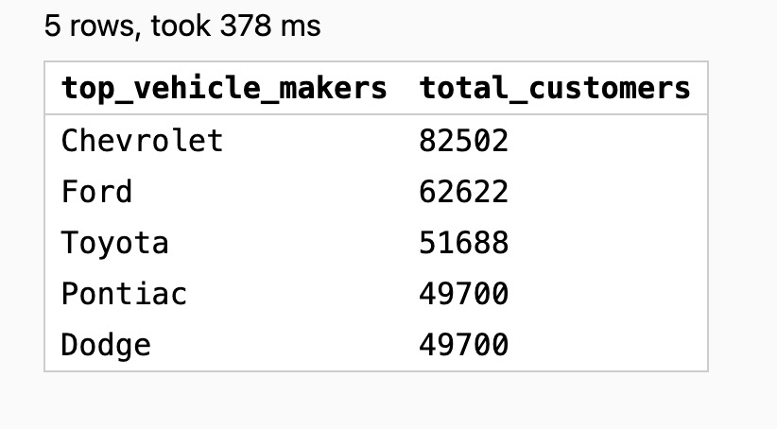
Observations:
- Chevrolet has the highest customer base (~82.5K), leading by a significant margin
- Ford (~62.6K) and Toyota (~51.7K) are the next major contributors
- Pontiac and Dodge have identical customer counts (~49.7K each)
- The top 3 vehicle makers account for the most of customers, indicating strong brand concentration
- Customer distribution drops noticeably after the top-ranked brand

Insights:
- Chevrolet appears to have strong brand penetration and customer preference
- Ford and Toyota act as primary competitive challengers in the market
- Pontiac and Dodge likely target similar customer segments, suggesting potential market overlap
- Heavy reliance on top vehicle makers could create market dependency risks
- Lower-ranked makers present potential growth opportunities through targeted marketing and product differentiation

Question 3: Which is the most preferred vehicle maker in each state?
Solution Query:
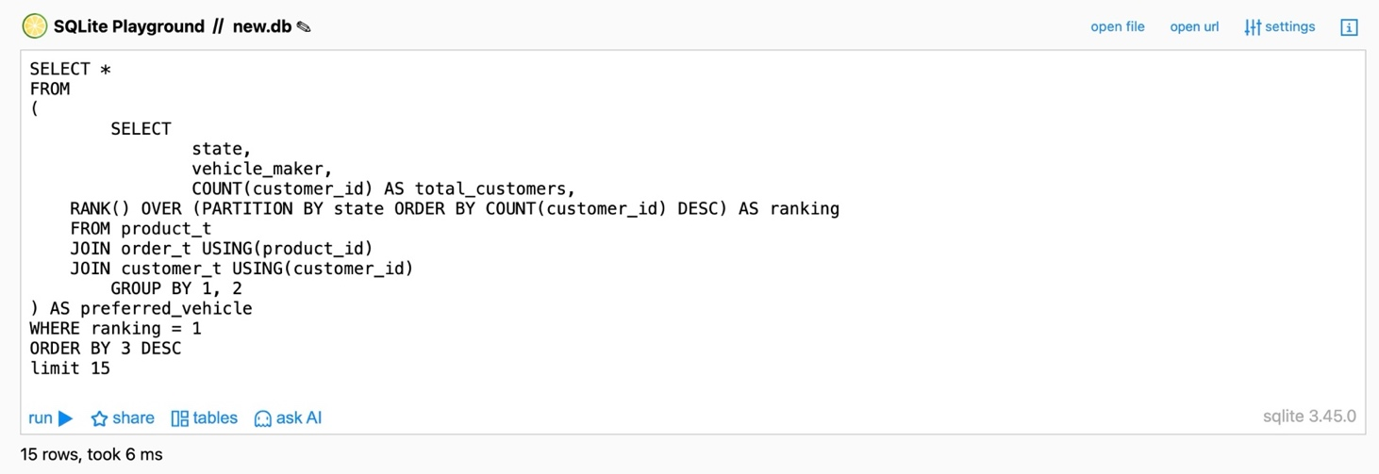
Output:
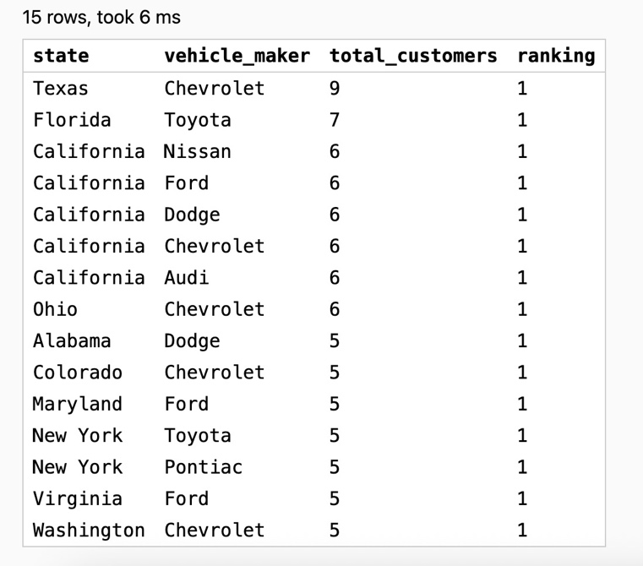
Note: The actual output contains 143 records; however, it has been restricted to 15 records due to space limitations
Observations:
- Chevrolet appears as the top-ranked vehicle maker across multiple states, indicating strong geographic presence
- Toyota and Ford consistently emerge as major competing brands across several high-volume states
- Large states such as California and New York show diversified customer preference with multiple brands sharing top rank
- Several smaller states show fragmented demand with multiple vehicle makers tied at low customer counts

Insights:
- Chevrolet demonstrates strong nationwide brand penetration and customer acceptance
- Toyota and Ford act as primary competitive challengers in key markets
- Highly competitive states indicate lower brand loyalty and require differentiation-focused marketing strategies
- Fragmented markets present potential growth opportunities through targeted regional marketing and expansion strategies

Question 4: Find the overall average rating given by the customers. What is the average rating in each quarter?

Consider the following mapping for ratings: “Very Bad”: 1, “Bad”: 2, “Okay”: 3, “Good”: 4, “Very Good”: 5
Solution Query:
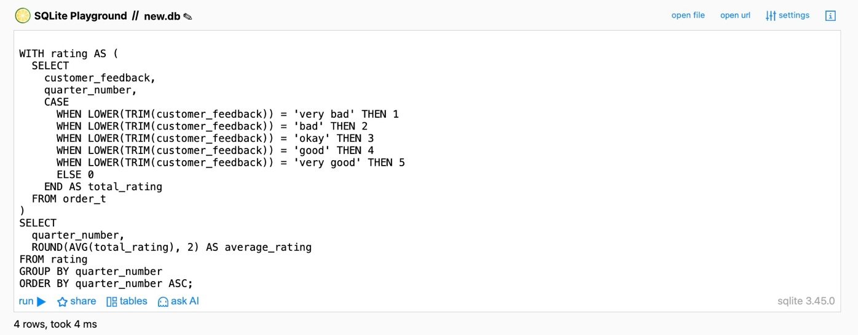
Output:
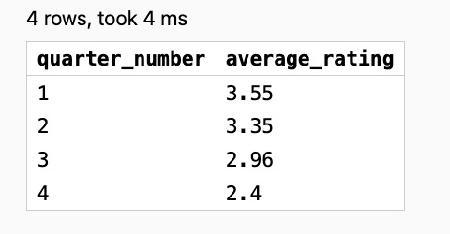
Observations:
- Average customer rating declines steadily across quarters, dropping from 3.55 in Q1 to 2.40 in Q4
- Q1 records the highest customer satisfaction level, indicating relatively strong service or product
- The largest decline occurs between Q3 (2.96) and Q4 (2.40), suggesting a significant drop in customer sentiment in the final quarter
- From Q2 onwards, average ratings consistently fall below 3.5, indicating moderate to declining satisfaction levels over time

Insights:
- The continuous downward trend signals potential deterioration in service quality, product performance, or customer experience across the year
- The sharp drop in Q4 suggests operational, seasonal, or delivery-related challenges that may require immediate investigation
- Maintaining Q1 service standards across subsequent quarters could help stabilize customer satisfaction levels
- Proactive feedback analysis and corrective action planning are required to prevent further decline and improve customer retention

Question 5: Find the percentage distribution of feedback from the customers. Are customers getting more dissatisfied over time?
Solution Query:
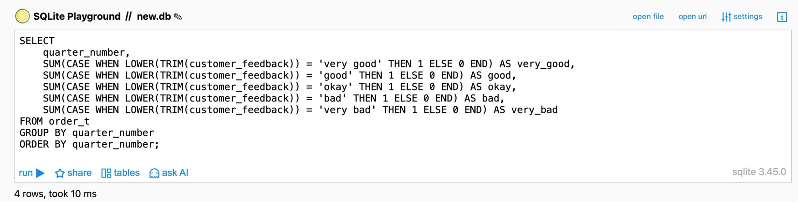
Output:
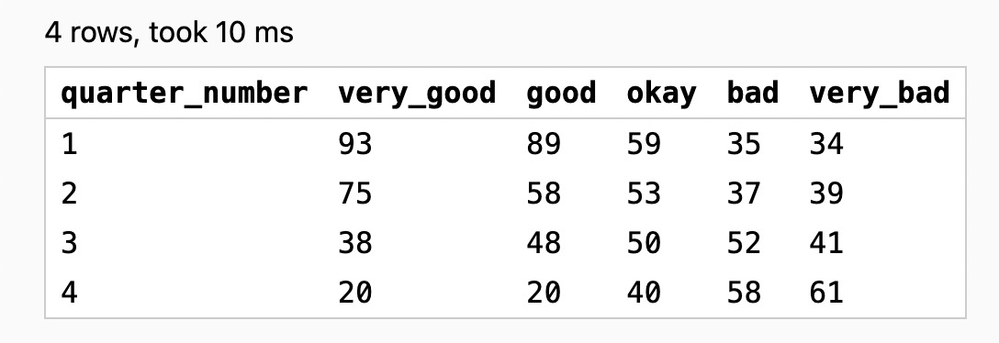
Observations:
- Customer satisfaction declines consistently across quarters, with average ratings dropping from 3.55 in Q1 to 2.40 in Q4
- Q1 shows the strongest customer sentiment, with the highest share of positive feedback (Very Good + Good)
- Negative feedback (Bad + Very Bad) increases steadily over time, overtaking positive feedback by Q3
- The steepest deterioration occurs between Q3 and Q4, driven by a sharp rise in Very Bad ratings

Insights:
- The sustained downward trend indicates progressive deterioration in customer experience across the year
- The sharp Q4 decline suggests operational, seasonal, or delivery-related issues that require urgent review
- Restoring and maintaining Q1 service standards could help reverse declining customer sentiment
- Early detection of negative feedback trends and timely corrective actions are critical to prevent further customer churn

Question 6: What is the trend of the number of orders by quarter?
Solution Query:
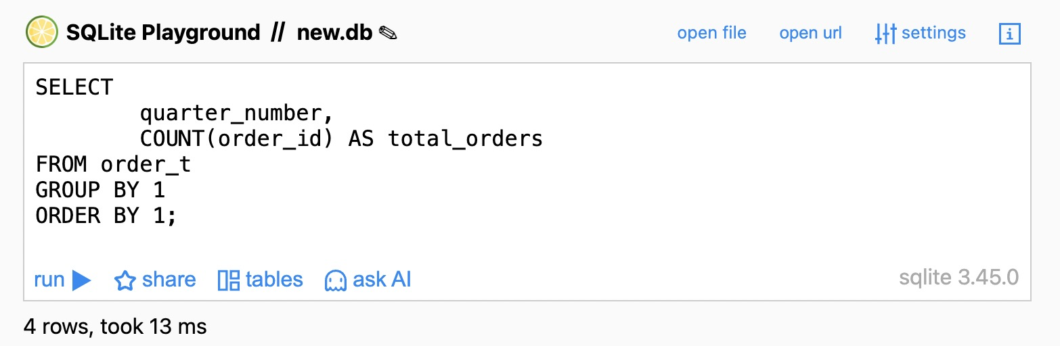
Output:
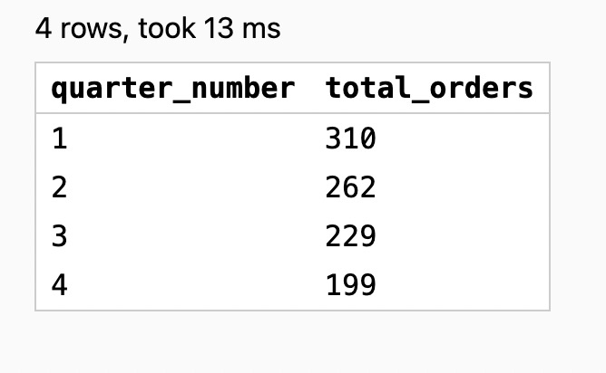
Observations:
- Total orders show a consistent quarter-on-quarter decline, dropping from 310 in Q1 to 199 in Q4
- Q1 records the highest order volume, indicating strong demand at the beginning of the year
- Orders decrease steadily each quarter, with no recovery or stabilization phase observed
- The largest absolute drop occurs between Q1 and Q2, followed by continued softening through Q4

Insights:
- The sustained downward trend suggests weakening customer demand or engagement over time
- Absence of any rebound indicates that underlying issues were not corrected early in the year
- The sharp early decline highlights the need for proactive monitoring and timely interventions
- Re-examining Q1 strategies (pricing, promotions, service levels) could help arrest and reverse the declining order trend

Question 7: Calculate the net revenue generated by the company. What is the quarter-over-quarter % change in net revenue?
Solution Query:
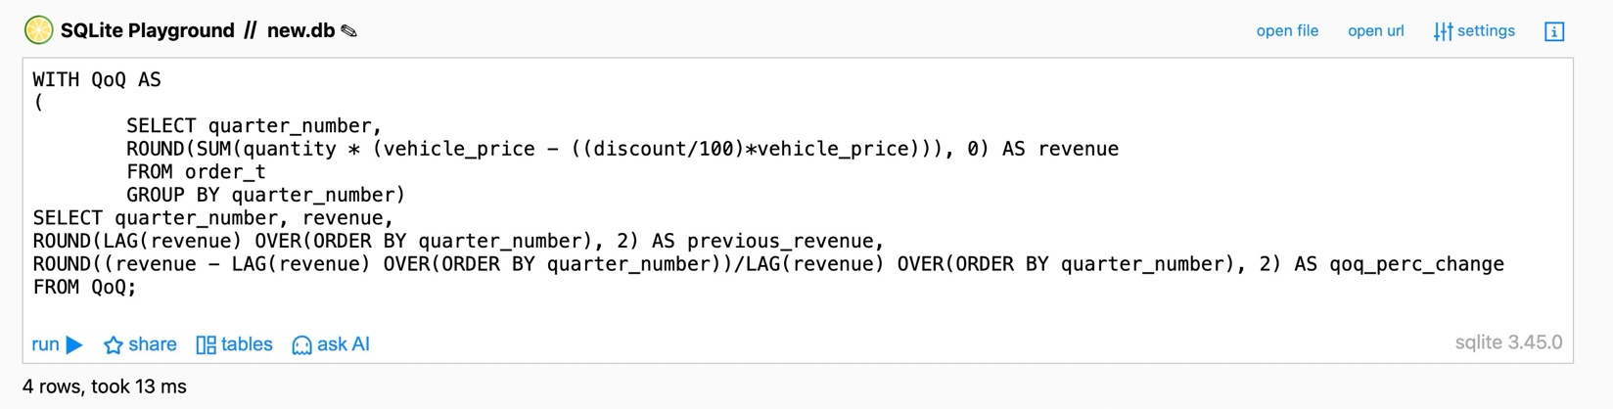
Output:
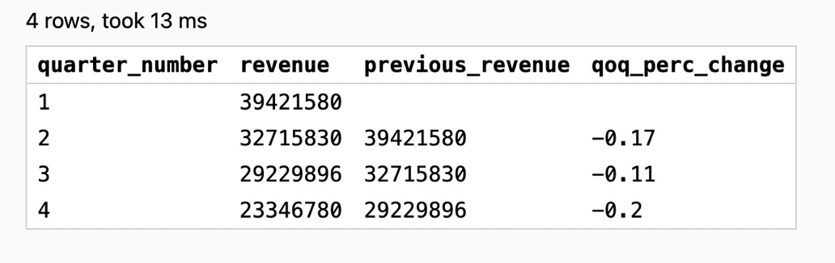
Observations:
- Revenue shows a consistent quarter-on-quarter decline, falling from 39.4M in Q1 to 23.3M in Q4
- Q1 generates the highest revenue, setting a strong baseline at the start of the year
- Revenue drops by 17% in Q2, followed by a 11% decline in Q3
- The steepest decline occurs in Q4, with a 20% QoQ drop, indicating accelerated revenue erosion

Insights:
- The sustained negative QoQ growth highlights persistent revenue pressure throughout the year
- The sharper decline in Q4 suggests compounding effects of lower demand, pricing pressure, or higher discounting
- Early revenue contraction in Q2 indicates that corrective measures were either delayed or ineffective
- Stabilizing revenue requires addressing both volume decline and discount strategy, particularly before entering later quarters

Question 8: What is the trend of net revenue and orders by quarters?
Solution Query:
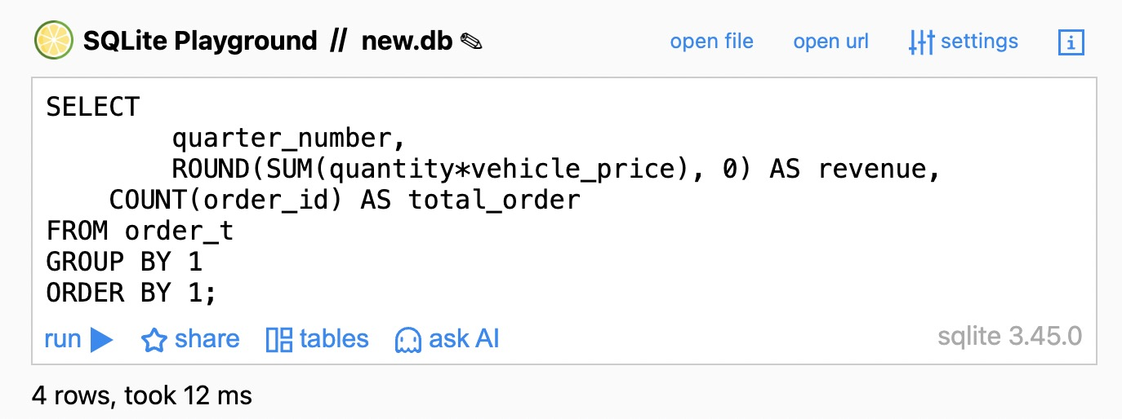
Output:
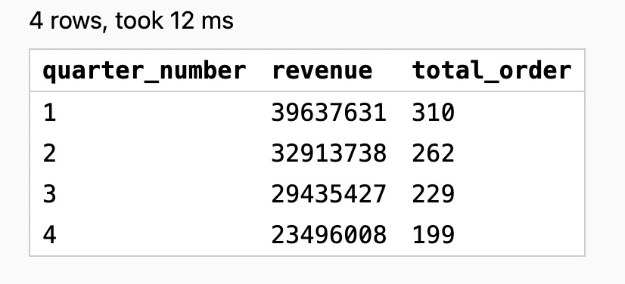
Observations:
- Both revenue and order volume decline consistently across quarters, indicating a parallel downward trend
- Q1 records the highest performance with ~39.6M revenue and 310 orders, serving as the annual peak
- Revenue decreases in line with falling order counts, suggesting volume-driven revenue contraction
- Q4 shows the lowest revenue (~23.5M) and order volume (199), marking the weakest quarter of the year

Insights:
- The strong alignment between declining orders and revenue indicates that volume loss is the primary driver of revenue erosion, rather than pricing alone
- The absence of any quarter-level stabilization suggests structural demand or engagement issues rather than a one-time disruption
- Q4’s weak performance reflects compounded effects of sustained demand decline, making recovery more difficult in later periods
- Improving revenue will require reversing order volume trends first, supported by targeted demand-generation and retention strategies

Question 9: What is the average discount offered for different types of credit cards?
Solution Query:
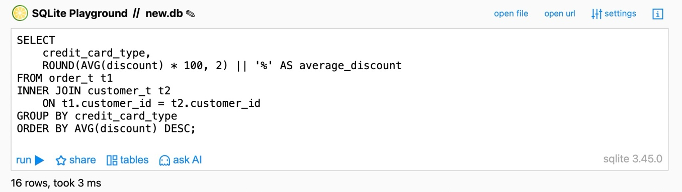
Output:
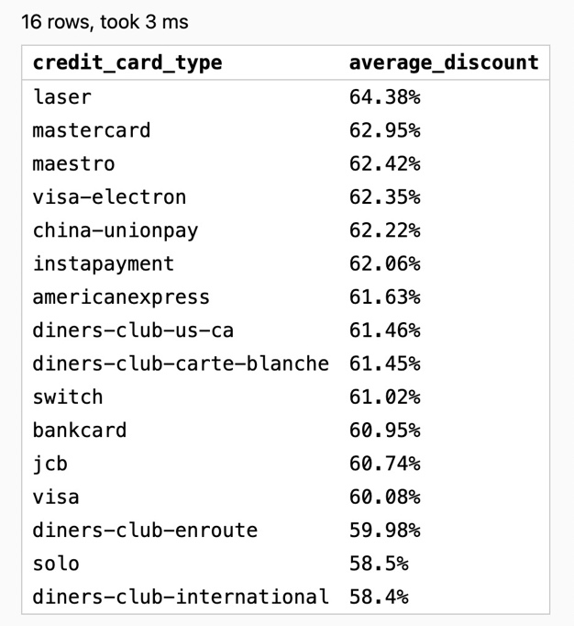
Observations:
- Average discounts remain consistently high across all credit card types (≈58%–64%)
- Laser, Mastercard, and Maestro receive the highest average discounts
- Minimal variation across card types indicates little differentiation in discounting

Insights:
- The uniform discount pattern suggests a non-targeted discount strategy
- High discounts across all cards may be pressuring margins without clear payoff
- Card-specific discount optimization could improve profitability while maintaining demand

Question 10: What is the average time taken to ship the placed orders for each quarter?
Solution Query:
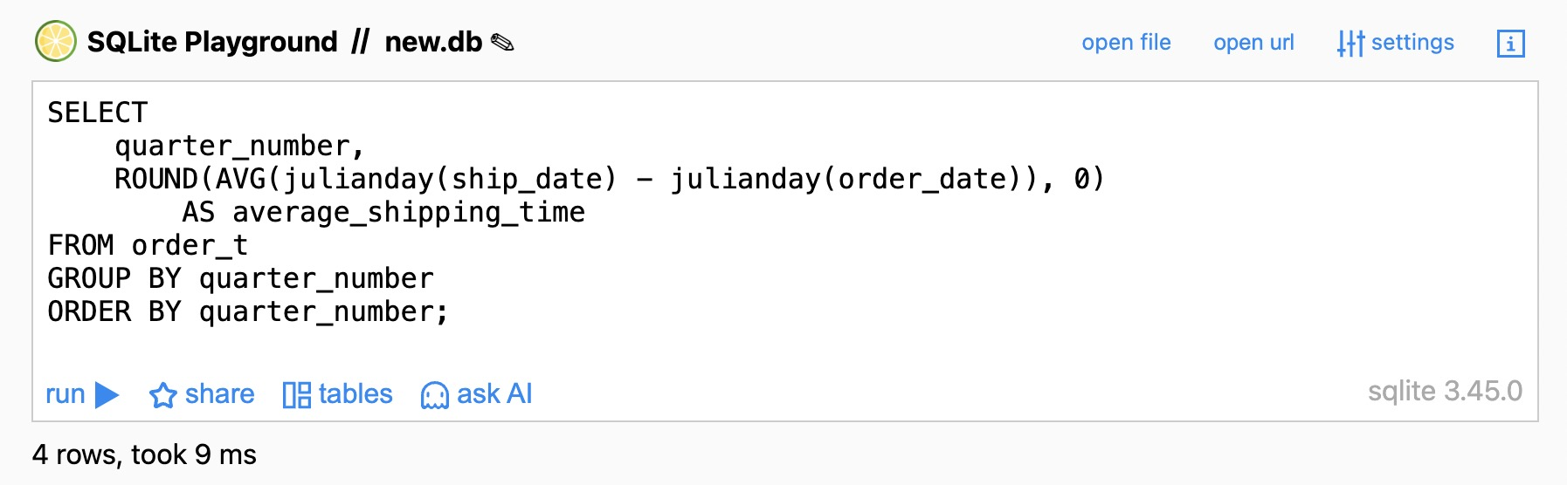
Output:
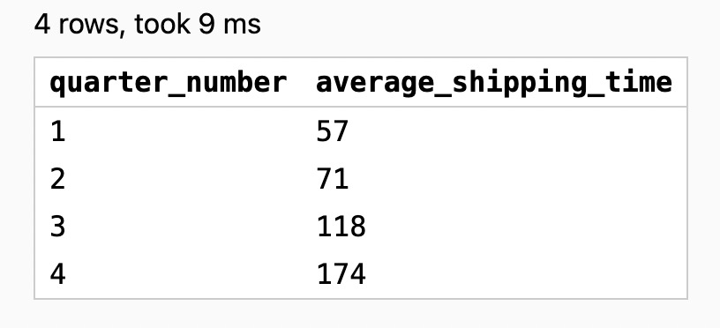
Observations:
- Average shipping time increases sharply quarter over quarter, rising from 57 days in Q1 to 174 days in Q4
- Each quarter shows a significant deterioration, with no signs of stabilization
- Q3 to Q4 records the steepest increase, indicating severe late-year delays

Insights:
- The consistent rise in shipping time suggests progressive operational or logistics breakdowns
- Prolonged shipping delays likely contribute to declining customer satisfaction and order volume
- Immediate intervention is required to identify bottlenecks and restore shipping SLAs, especially before peak periods

Business Metrics Overview
Total Revenue | Total Orders | Total Customers | Average Rating
~125M | 1000 | 994 | 3.13
Last Quarter Revenue | Last quarter Orders | Average Days to Ship | % Good Feedback
~23.5M | 199 | 98 | 44.1%

Executive Summary
- Business performance declined steadily across the year, with total orders falling from 310 in Q1 to 199 in Q4 and revenue dropping from ~39.6M to ~23.5M in the last quarter
- Customer experience deteriorated significantly, reflected in declining average ratings (3.55 → 2.40), low good-feedback share (44.1%), and sharply increasing shipping delays (57 days → 174 days)
- Shipping delays emerged as a critical driver, strongly correlating with reduced customer satisfaction, lower repeat demand, and revenue erosion
- Q4 represents the weakest quarter across all key metrics, indicating compounded operational and customer-experience issues rather than isolated disruptions
- Immediate focus on fulfilment efficiency, customer feedback management, and product mix optimization is required to stabilize demand and prevent further revenue loss

Business Recommendations
- Prioritize improvements in shipping and fulfilment, as rising delivery time (98 days) strongly correlates with declining ratings (average 3.13) and feedback quality
- Address customer experience gaps by analyzing feedback trends and acting early on negative sentiment signals (only 44.1% good feedback)
- Investigate the sharp Q4 order decline (199 orders) to identify demand loss driven by service delays or post-purchase experience
- Break down last-quarter revenue decline (23.5M) to distinguish volume-driven losses from pricing or discount impact
- Optimize the product mix by strengthening supply for top-selling items and reassessing consistently low-performing products to prevent revenue leakage

